REQUEST CLASS:
- structured form of client input: requested action, sender, recipient, and content
- examples:
  - type: login
  - sender: user1
  - recipient: null
  - content: password

- type: send_message
- sender: user1
- recipient: user2
- content: message

@startuml

title Request Class

enum RequestType {

' AUTHENTICATION:
LOGIN
LOGOUT
REGISTER

' PRIVATE MESSAGING:
SEND_MESSAGE
LOAD_CHAT_HISTORY

' CONTACTS:
VIEW_CONTACTS
ADD_CONTACT
REMOVE_CONTACT

' GROUPS:
CREATE_GROUP
VIEW_GROUP
ADD_TO_GROUP
REMOVE_FROM_GROUP
SEND_GROUP_MESSAGE
LOAD_GROUP_HISTORY

}

class Request {

' ATTRIBUTES:

' defines action being requested
- RequestType type
' user making the request
- String sender
' target user or group
- String recipient
' data (message, user, password, etc.)
- String content

' METHODS:
' constructor
+ Request(RequestType type, String sender, String recipient, String content)
' returns request type
+ RequestType getType()
' returns sender username
+ String getSender()
' returns recipient
+ String getRecipient()
' returns data
+ String getContent()
}

@enduml

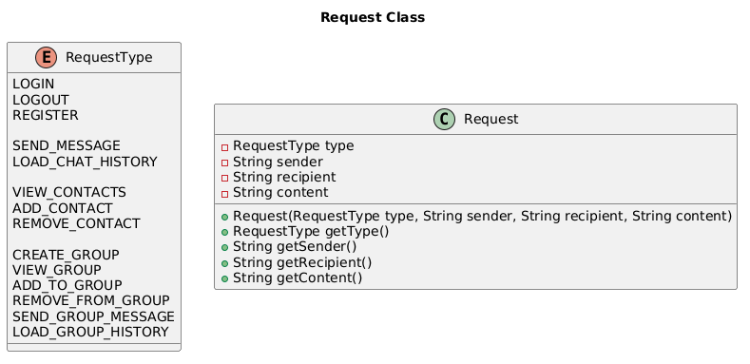
CLIENTHANDLER CLASS:
- manages communication between client and server
- receives input, converts into request, routes request to appropriate handler, sends response back to client

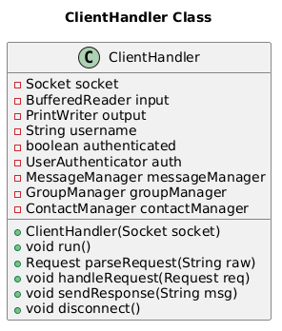
@startuml
title ClientHandler Class

class ClientHandler {

' ATTRIBUTES:

' network connection
- Socket socket
' reads incoming messages
- BufferedReader input
' sends responses
- PrintWriter output
' current user
- String username
' login status
- boolean authenticated
' handles authentication
- UserAuthenticator auth
' handles messaging
- MessageManager messageManager
' handles group operations
- GroupManager groupManager
' handles contacts
- ContactManager contactManager

' METHODS:

' constructor
+ ClientHandler(Socket socket)
' listens for client input
+ void run()
' converts input into Request
+ Request parseRequest(String raw)
' routes request and delegates
+ void handleRequest(Request req)
' sends response to client
+ void sendResponse(String msg)
' closes connection
+ void disconnect()
}

@enduml

USERAUTHENTICATOR CLASS:
- handles user authentication by validating credentials, registering users (IT), and tracking active sessions

@startuml

title UserAuthenticator class

class UserAuthenticator {

' ATTRIBUTES:
' stores username, password
- Map<String, String> userCredentials
' tracks usernames of active users
- Set<String> activeSessions

' METHODS:
' constructor
+ UserAuthenticator()
' verifies credentials and logs user in if valid
+ boolean authenticate(String username, String password)
' removes from active uses, ends session
+ void logout(String username)
' checks if a username is already registered
+ boolean userExists(String username)
' registers user if username is not taken
+ void registerUser(String username, String password)
' prevents duplicate logins
+ boolean isLoggedIn(String username)
}

@enduml
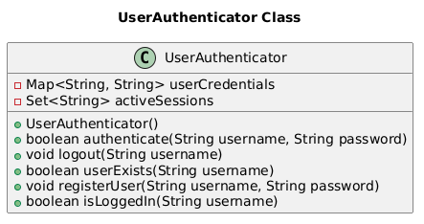

CONNECTIONMANAGER CLASS:
- manages all active client connections
- accepts new clients, tracks connected users, helps enable communication

@startuml

title ConnectionManager Class

class ConnectionManager {

' ATTRIBUTES:

' listens for incoming client connections
- ServerSocket serverSocket
' stores all currently connected clients
- List<ClientHandler> activeClients
' maps usernames to their active client handlers
- Map<String, ClientHandler> userMap

' METHODS:

' constructor
+ ConnectionManager(int port)
' continuously accepts new client connections
+ void startListening()
' adds a new client to active list
+ void addClient(ClientHandler client)
' removes client when they disconnect
+ void removeClient(String username)
' retrieves active client by username
+ ClientHandler getClient(String username)
}

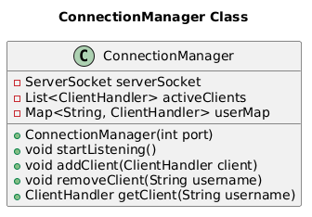
@enduml

STORAGEMANAGER CLASS:
- handles persistent data storage and retrieval
- ensures data is saved and accessible

@startuml

title StorageManager Class

class StorageManager {

' ATTRIBUTES:
' file path where user credentials are stored
- String userFilePath
' directory where message history is stored
- String messageDirectory

' METHODS:

' constructor
+ StorageManager(String userFilePath, String messageDirectory)
' saves a new user's credentials
+ void saveUser(String username, String password)
' loads all users from storage
+ Map<String, String> loadUsers()
' saves a message between users
+ void saveMessage(String sender, String recipient, String content)
' retrieves chat history between two users
+ List<String> loadChatHistory(String user1, String user2)
' stores a message for offline delivery
+ void storeOfflineMessage(String recipient, String message)

}

@enduml
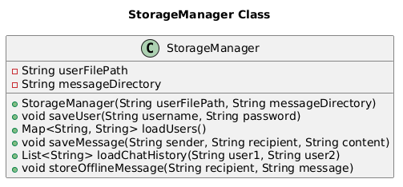

LOGGINGMANAGER CLASS
- records system events, warnings, and errors

@startuml

title LoggingManager Class
class LoggingManager {

' ATTRIBUTES:

' file path where logs are stored
- String logFilePath
' temporary buffer for storing logs all at once
- List<String> logBuffer

' METHODS:

' constructor
+ LoggingManager(String filePath)
' logs normal system events (message, valid logins)
+ void logInfo(String message)
' logs warning events
+ void logWarning(String message)
' logs error events
+ void logError(String message)
' writes buffered logs to file
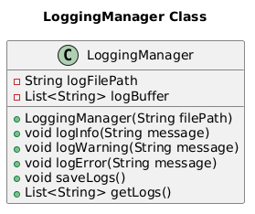
+ void saveLogs()
' retrieves current logs
+ List<String> getLogs()

}

@enduml

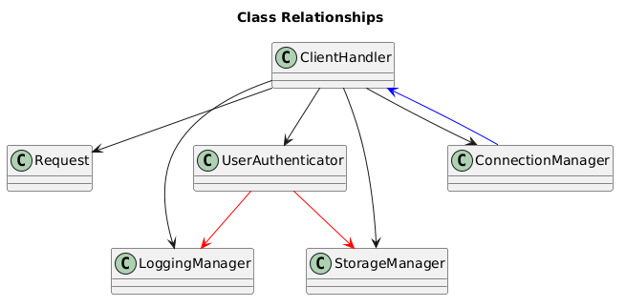
CLASS RELATIONSHIPS:

@startuml

title Class Relationships

class ClientHandler
class Request
class UserAuthenticator
class LoggingManager
class StorageManager
class ConnectionManager

' RELATIONSHIPS

ClientHandler --> Request
' ClientHandler parses input into Request objects
‘ necessary to handle raw strings sent over Server

ClientHandler --> UserAuthenticator
' ClientHandler uses UserAuthenticator to handle login, logout, and registration

ClientHandler --> LoggingManager
' ClientHandler receives requests and uses LoggingManager to log those events (requests, errors, actions)

ClientHandler --> StorageManager
' ClientHandler uses StorageManager to retrieve/store data as needed

ClientHandler --> ConnectionManager
' ClientHandler uses ConnectionManager to connect with other clients

UserAuthenticator -[#red]-> StorageManager
' UserAuthenticator uses StorageManager to retrieve/store user credentials

UserAuthenticator -[#red]->LoggingManager
' UserAuthenticator uses LoggingManager to track login attempts and authentication events

ConnectionManager -[#blue]-> ClientHandler
' ConnectionManager maintains list of active ClientHandlers

@enduml

